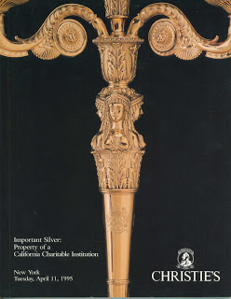

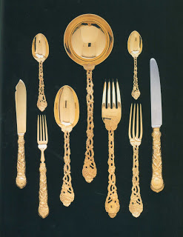
Elizabeth II Gold Table Service 14 karat
Used at all dinners in HWA's dining room
Auction estimate $50,00-80,000

-----------------------

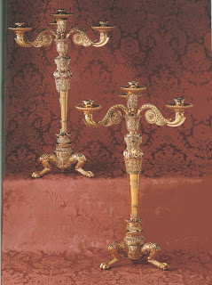
Regency Silver-gilt Four Light Candelabra, Benjamin Smith, 1812
These sat on the buffet in the dining room. They were also used on the dining table.
Auction estimate $80,000-120,000

---------------------

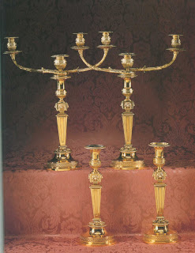

George III Silver-gilt Candelabra and matching candlesticks, Paul Storr, 1802
Auction estimate $60,000-90,000

------------------------

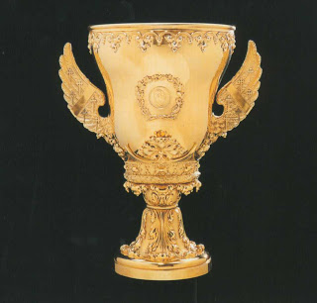
The Duke of Norfolk's Coronation Cup
William IV Silver-gilt Paul Storr, 1831
Auction estimate $20,000-30,000

---------------------------------------

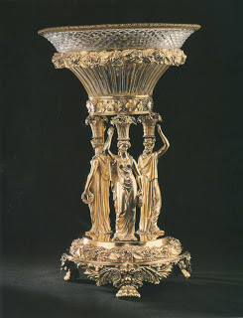
Regency Silver-gilt Centerpiece, Paul Storr, 1818
The Three Graces occupied the place of distinction on HWA's dining room table.
Auction estimate $30,000-50,000

------------------------------------

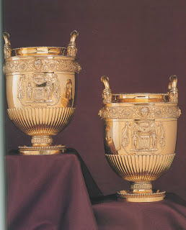

Regency Silver-gilt Wine Coolers, Paul Storr 1813
Used to keep the hundred dollar wine bottles cool
Auction estimate $60,000-90,000

---------------------------
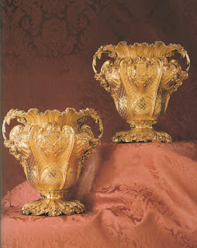
A pair of George IV Silver-gilt Wine Coolers 1826
Imagine chilling your wine and champagne at home in these!
Auction estimate $50,000-80,000

----------------------------

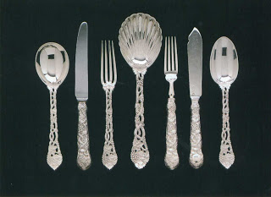
The sterling silver pictured here is an Elizabeth II Table service. Service for 12.
This was HWA's everyday silver.
Auction estimate: $10,000-15,000
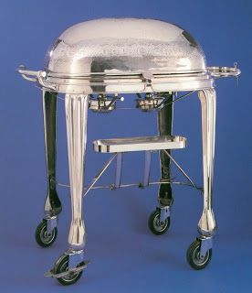
This was to keep HWA's roast beef warm. Estimated value $5,000-$8,000

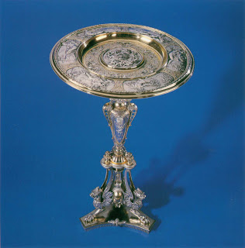
A Victorian Parcel-Gilt Silver Plated Table for your guests to place their calling cards on. $4,000-$6,000

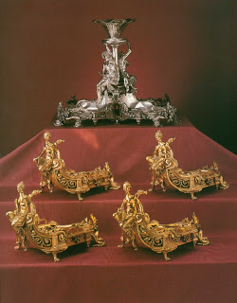
Set of late 1800's silver centerpiece with glorious naked women on it. $10,000-$15,000
late 1800's Gold Desert dishes $4,000-$6,000

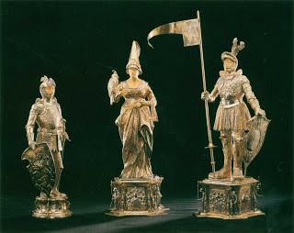

German Silver Knight $3,000-$5,000
Pair of German Silver Figures, Sir Lancelot and Lady Guinevere $10,000-$15,000

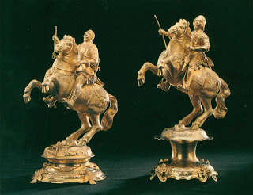
Elizabeth II Equestrians $6,000-$9,000 each

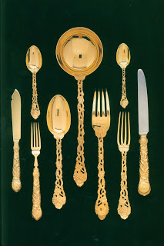
Elizabeth II 14 kt Gold Table Service (This was used for formal dinners) $50,000-$80,000

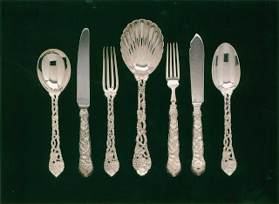

Sterling Silver Everyday service $10,00-$15,000

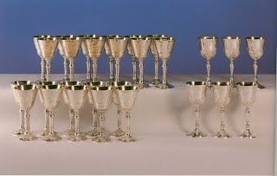
Silver Goblet's to drink your Harvey's Bristol Cream In $8,000-$12,000

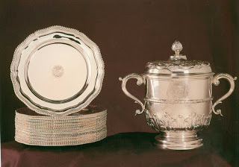
Set of 22 Silver Dinner Plates $8,000-$12,000

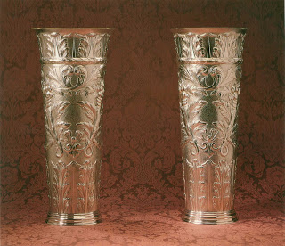
George V Sterling Silver Umbrella Stands $10,000-$15,000
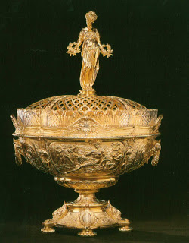

Victorian Gilt Centerpiece 1888
Goddess Ceres in a field of wheat
$8,000-12,000
Sold for $23,300.00

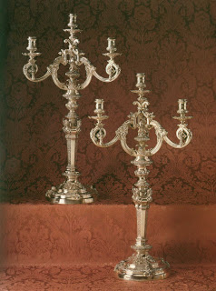

Victorian Silver Four-light Candelabra 1857
$20,000-30,000
Sold for $57,500.00

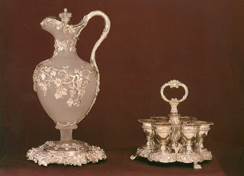

Victorian Silver-mounted Frosted-glass Claret Jug and Stand 1845
$4,000 - 6,000
George IV Silver Egg Cruet 1820
$2,500 - 3,500
(HWA had this on his breakfast table in the kitchen for his soft boiled eggs)
Sold for $27,600.00

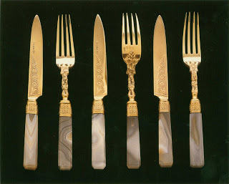

Victorian Silver-gilt and Agate Desert Service 1854
$3,000 - 5,000
Sold for $4,370.00

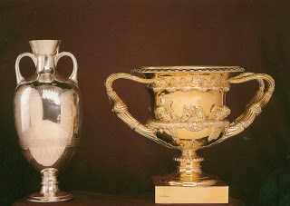

Victorian Silver Vase 1874
$2,000 - 3,000
Sold for $2,700.00
Edward VI Silver-gilt Warwick Vase
$5,000 - 8,000
Sold For $5,650.00

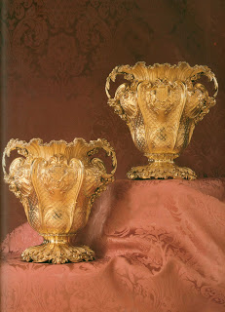
George IV Silver-gilt Wine Coolers 1826
$50,000 - 80,000
Sold for $74,000.00

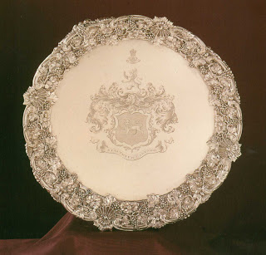
Regency Silver Salver 1813
$7,000 - 10,000
Sold for $24,150.00

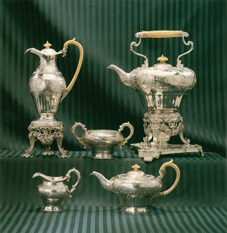
George IV Silver Tea and Coffee Service
$10,000 - 15,000
Sold for $16,100.00

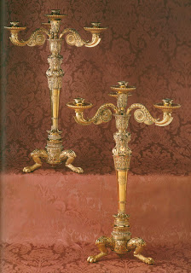
Important Regency Silver-gold gilt Candelabra 1812
$80,000 - 120,000
Sold for $222,500.00
+++++++++++++++++++++++
These items are vital tools for Ambassadors of World Peace!
You too can talk to Mrs. Sadat about a world that is ready to be spanked!
Well, I guess that one came true........

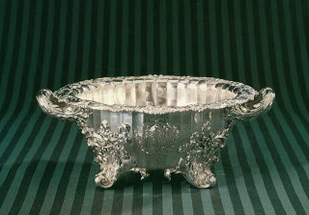
Regency Silver Bowl 1818
Paul Storr
$15,000 - 25,000
Sold for $27,600.00

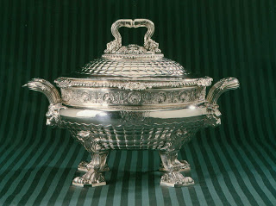
Regency Silver Soup Tureen, cover and liner
Paul Storr, 1814
$30,000-50,000
Sold for $28,750.00

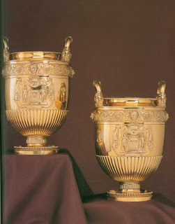
Regency Silver-Gilt Wine Coolers
Paul Storr, 1813
$60,000-90,000
Sold for $107,000

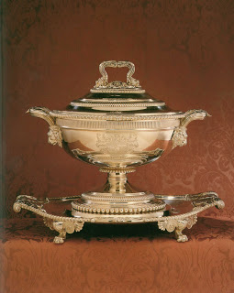
George III Silver Tureen and Cover and Stand
Paul Storr, 1809
$40,000-60,000
Sold for $51,750.00

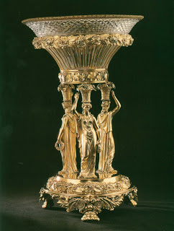
Regency Silver-gilt Centerpice
Paul Storr, 1818
$30,000-50,000
Three Bacchic Nymphs
Sold for $48,300.00

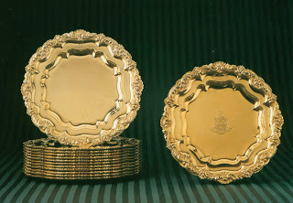
Twelve Regency Silver-Gilt Dinner Plates
Paul Storr, 1815
$30,000-50,000
Not listed as sold
Regency Silver Gilt Salver
Paul Storr, 1815
$2,000-3,000
Sold for $1,950.00

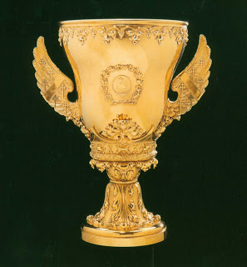
Duke of Norfolk's Coronation Cup
Paul Storr, 1831
$20,000-30,000
Sold for $18,400.00

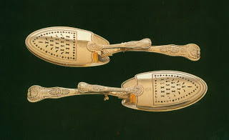
Regency Silver-gilt Serving Tongs Made For The Prince Regent
Paul Storr, 1811
$6,000-8,000
Sold for $10,350.00

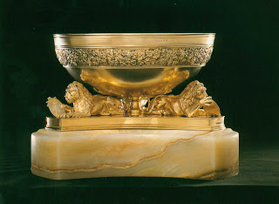
George III Silver Gilt Centerpiece
1803
$15,000-25,000
Sold for $40,250.00

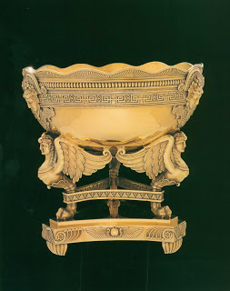

George III Silver-gilt Centerpice
Paul Storr, 1808
$20,000-30,000
Sold for $52,900.00

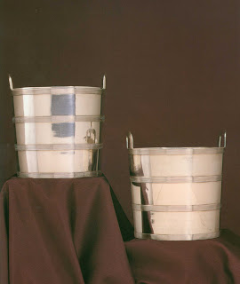
George III Silver Wine Collers
Paul Storr 1798
$25,000-35,000
Sold for $48,300.00

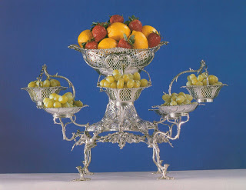
George III Silver Epergne
1770
$8,000-12,000
Sold for $12,650.00

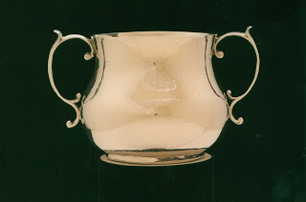
Charles II Silver Caudle Cup
1667
$3,000-5,000
Sold for $3,680.00

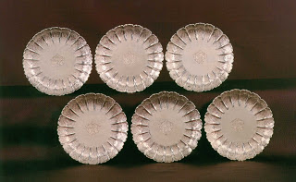
Six Queen Anne Silver Fluted Dishes
1713
$30,000-50,000
Sold for $74,000
++++++++++++++++++++++++

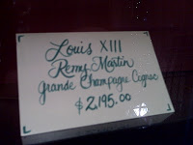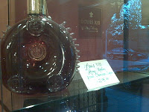
Pictured above is the current price of Louis XIII Remy Martin Grande Champagne Cognac.
- See more at: http://armstrongismlibrary.blogspot.com.au/p/treasures-of-king.html#sthash.7LmrfcKR.dpuf

