DRAFT

RADIO CHURCH OF GOD
&
HERBERT W ARMSTRONG

HISTORICAL TRAIL

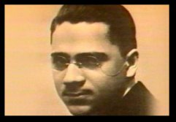 | 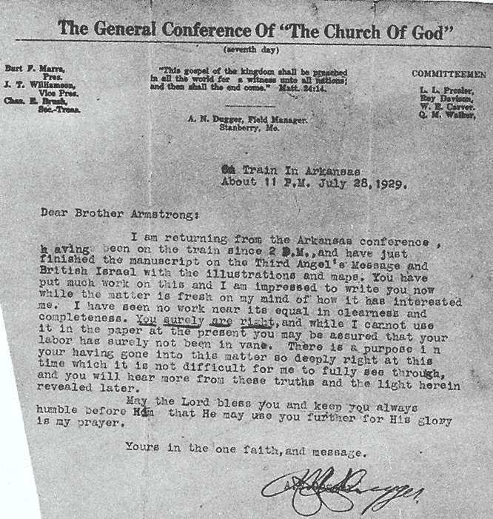 | 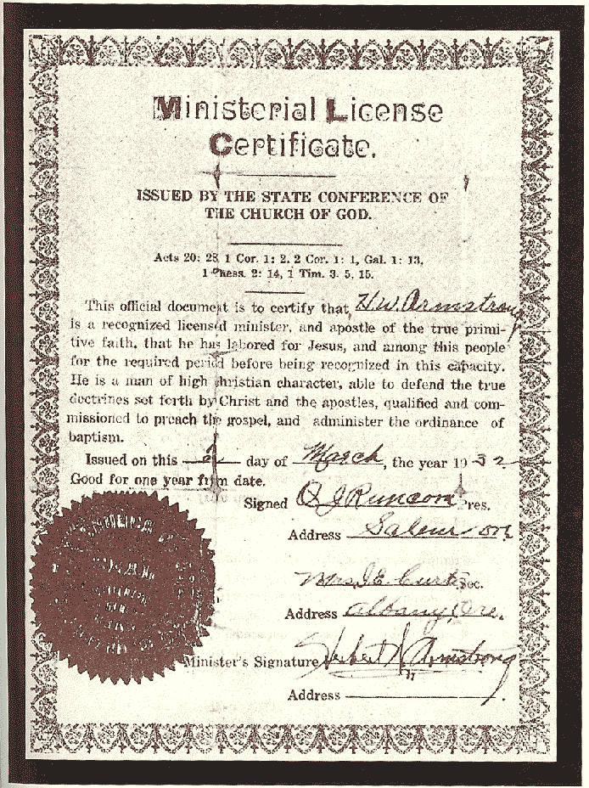 | 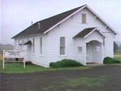 | 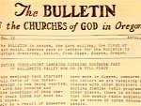 | 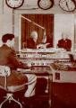 | 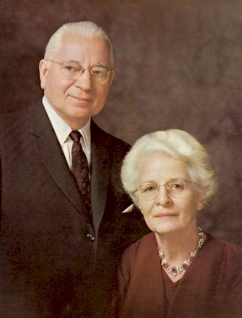

Assembled by Craig M White

Version 1.0

For many years I have had great interest in the history of the sabbatarian movement from its foundations in the first century.

I noticed that the Seventh day Baptists and Seventh-day Adventists have kept very good historical records the history of their groups – see for example http://sdbhistory.org/ and http://www.aplib.org/, http://washington.netadvent.org/ and so on.

The information below has been collected from data collected from The Autobiography of Herbert W Armstrong, the internet and a trip I undertook in October 2011 to Portland, Eugene and Willamette Valley in Oregon. Data was also supplied by Pastor Randy Stiver (United Church of God), Pastor Larry Walker (United Church of God), Pastor John Lemley (Church of God (seventh day), Al Stout and Ben Light.

YEAR/DATE | PLACE | LOCATION DETAILS/ADDRESS | COMMENT | REFERENCE | MY PHOTOGRAPHS | PHOTOGRAPHS BY OTHERS
1920s | Portland Multnoma County Public Library | 801 Southwest 10th Avenue, Portland | where HWA did his initial research? | “At the same time, I found, in the Portland Public Library, many scientific works either  directly on evolution, or as a teaching in textbooks on biology, paleontology and geology.  Also I found books by scientists and doctors of philosophy puncturing many holes in the  evolutionary hypothesis.”
1933 | Jeans Schoolhouse | now a private residence and must be photographed discreetly apparently | on Old Emira Road (12 miles west of Eugene and a mile or so west of the west side of Fern Ridge Resevoir, now a private residence)
1933 | Alvadore school | 15 miles NW of Eugene |  | Auto, p. 577
1933 | Harrisburg, Oregon | a small town on US Hwy 99E immediately north of where the highway goes over the bridge across the Willamette River on the way south to Junction City and Eugene. | This town was the site of an evangelistic campaign that Mr. A. conducted shortly before the one at the Fir Butte School.
1933 | Firbutte School | 8 miles west of Eugene, now under the shallow side of the Fern Ridge Reservoir on the Old Elmira Road—now called Royal Road. You can see where the roadbed going into the east wetland of the reservoir.
 | Grant St. house in Eugene | Xx Grant St | owned by the Armstrongs at one time until selling it to fund the Work
1934 | 4th St. house in Eugene | Xx 4th Street | one of the many places they rented after selling their house in a neighborhood several blocks west of the Amtrak rail station | “But by late March I had rented a house on West 4th. I think the rent was about $7 per  month. I had arranged for meetings to start in the Old Masonic Temple on Seventh  Avenue.” |  | see picture in Auto vol. 1
1935 to 1959 | 8th Street in Eugene - site of the first church building | on 8th St. just a few yards west of the intersection of 8th and Taylor St. 8th Street in Eugene – site of the first church building where the Jeans, Firbutte and Alvadore brethren consolidated to form the Eugene congregation. | Site of the “little church way out on 8th St (church building in Eugene for many years—from 1935 to 1959) | “On June first, 1935, The Church of God at Eugene, Oregon, held its first service in the  new building, consolidating the three groups into one church.”  P 580 - new church bldg at end of W 8th Ave., Eugene
1935 (Autumn) | Site of the first “Home Office” | on the corner of 6th and Willamette (now the Hult Performing Arts Center) | Downtown Eugene – where the first two church offices were rente. | “He said he had a vacant room in the Hampton Building, across from the Post  Office (a new Post Office has been built since) on the southwest corner of Sixth and  Willamette. However, he would have to charge me $5 per month office rent.”
 | second, larger office in Eugene—the old Oddfellows Hall | May be the current OF Hall on Charnelton Street between 12th and 13th. | second, larger office in Eugene |  |  | see picture in Auto vol. 2
 | Belknap Springs resort | about 55 or so miles up the McKenzie River highway east of Eugene; it’s right on Hwy 126 a few miles down the hill toward Eugene from the Hwy 20 junction near Santiam Pass). www.belknaphotsprings.com/ | First Feast site
 | Scravel Hill church building | near Jefferson (COG7 met there. HWA. often preached there) it’s at the top of the hill on Scravel Hill Road | is now a private residence, but the building design gives away what it was.
 | Milas Helms farm | location near Jefferson on the south bank of the Santiam River just west of I-5 across from the rest area on the north bank of the river | where the miracle of crops not destroyed by a spring flood occurred | Auto chapters 27 & 28
 | Amtrak Station | in Eugene - w5th Ave | where Mr. A. made many “shirt tail shoots” catching the train to travel or go to Pasadena to make broadcasts on the higher quality recording equipment found near Hollywood
1934 (Jan) | KORE radio station | located in 2080 Laura Street, Springfield (next door to Eugene) | this was the station that broadcast Mr. A’s first radio messages.
1934 (Dec) | Radio station - KSLM 345 | Court St, Salem | “By December that first year of broadcasting -- 1934 -- Christ OPENED A SECOND  DOOR. His time had come for the broadcast to leap to Portland, with ten times the  potential listeners. In fact, a hook-up was opened to us for two additional stations, KXL,  Portland, and KSLM, Salem -- both at that time only 100-watt stations. The cost was to  be $50 per month.”
 | The Multnomah Hotel | 319 Southwest Pine St., Portland | is now Embassy Suites. http://pdxhistory.com/html/multnomahhotel.html Don't know if HWA ever stayed there, but he used the radio station that was there... and it has an interesting history. KXL in Multnomah Hotel in Portland | Auto, p 599
1926? | Hinson Memorial Baptist Church | 1137 Southeast 20th Ave., Portland | This is where HWA chose to be baptised.
1934 (Nov) – 1935 (Jan) | Alvadore Schoolhouse | 8-10 miles northwest of Eugene and which is falling down (near Decker Nursery (90808 B Street) | – site of HWA’s third campaign and small congregation. Abandoned.  At one time Alvadore had a school; the building was later abandoned and it has since been demolished |  |  | 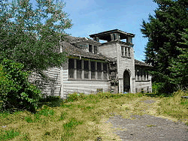
1934 (Oct) | HWA’s home | ??60 W. 4th St in Eugene | HWA lived at in on his Credentials of Discipleship
1934 | The Hampton bldg | on corner of 6th & Willamette in Eugene office | where 1st PT was published |  |  | 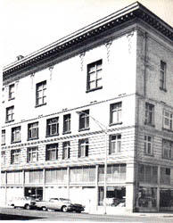
1934-1935 | Old Masonic Temple | on W. 7th Ave just off Willamette in Eugene | “Following the evangelistic meetings in the old Masonic Temple in downtown Eugene,  April and May, 1934, I had retained for some time, as mentioned above, the use of one of  the smaller rooms as an office. I do not remember just when, but later -- probably early  autumn, 1935 -- Mr. Frank Chambers, owner of the building (and somewhere near half of  all downtown Eugene, it was rumored), told me he had a tenant for the entire building,  and I would have to move.”  Meetings held here as well as temporary office | Auto p 546, 562
 | Pasadena | Move to Pasadena |  |  |  | 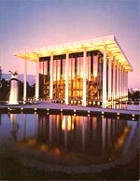
 | HWA’s grave | Altadena, Los Angeles County, California. Plot: Founder's Lawn, L-2110 |  | Mountain View Cemetery and Mausoleum

Appendix: Church of God (seventh day) sites in Oregon by John Lemley

- A.N. Dugger was the pastor in Marion, OR back in the '40s. The church is on the same site, but it is a different building: Marion Church of God (Seventh Day), 7478 Stayton Road. S.E., Turner, OR 97392. The house the Duggers lived in is still across the street.

- There is also a church in Harrisburg, OR. Not sure about how old it is or how long CG7 has owned it: Harrisburg Church of God (Seventh Day), 820 Diamond Hill Road, Harrisburg, OR 97446

- Eugene Church of God (Seventh Day): Meeting at Valley River Baptist Church, 1145 Willagillespie Road, Eugene, OR 97401

References

Armstrong, HW (1986) | Autobiography of Herbert W Armstrong (vol 1). Pasadena, California.
Armstrong, HW (1986) | Autobiography of Herbert W Armstrong (vol 2). Pasadena, California.
Nickels, RC | Early Writings of Herbert W Armstrong
White, C | GG Rupert. Man of God
White, C | Herbert W Armstrong. Man of God
White, C | Pioneers of the Worldwide Church of God
White, C | Worldwide Church of God Pioneer Timelines.
Nickels, RC (1999) | History of the Seventh Day Church of God (vol 1).
Nickels, RC (1999) | History of the Seventh Day Church of God (vol 2).
Nickels, RC (2004) | Six Papers on the History of the Church.

Oregon State Map
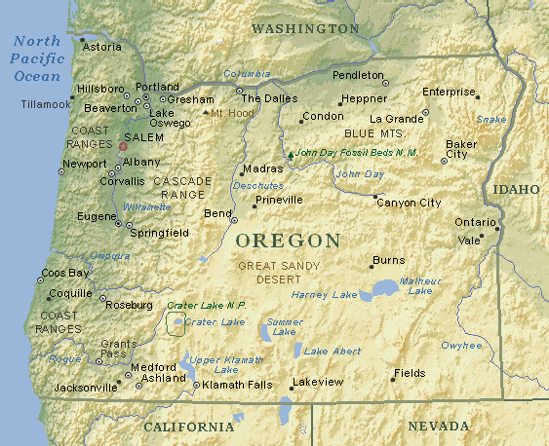

Portland to Eugene
