South Africa: “One Child Raped Every Three Minutes, Three Children Murdered Each Day.”
December 7, 2013 by Daniel Greenfield 11 Comments
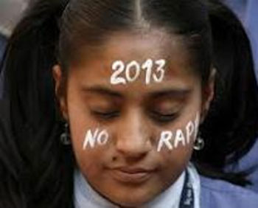
Liberals took credit for defeating Apartheid, took their bows and moved onignoring the mess they left behind. Here’s a letter from South Africa. The real South Africa, not the one where Morgan Freeman plays Mandela and everyone lives happily ever after.
South Africa is in a serious moral crisis. We are a violent society disintegrating by the day. Ghastly murders are committed daily.
We have become delusional. Forgetting that life is absolutely intrinsic and inviolable. Our country is awash with demonic monsters in human garb, savages fit only for the wild, and satanic beasts ill-equipped for civil society.
Is this the democracy we fought so hard for? One child raped every three minutes, three children murdered each day. We are sliding towards the edge of the abyss and our people are crying out for sanity to prevail.
Maybe all the Anti-Apartheid campaigners have some suggestions? Surely a boycott might help. I bet it would make the child rapists who are raping a child every 3 minutes rethink their ways?
No? They’re understandably busy. The world is full of problems. Rain forests are being chopped down, whales are choking on packets of crackers and somebody just droned a terrorist.
There’s plenty of things to be outraged about. And if you’re not outraged, you’re not paying attention. And if you’re not paying attention, you can always be outraged.
7

About Daniel Greenfield
Daniel Greenfield, a Shillman Journalism Fellow at the Freedom Center, is a New York writer focusing on radical Islam. He is completing a book on the international challenges America faces in the 21st century.

http://www.frontpagemag.com/2013/dgreenfield/south-africa-one-child-raped-every-three-minutes-three-children-murdered-each-day/

