South Africa in the Shadows
December 6, 2013 by Daniel Greenfield
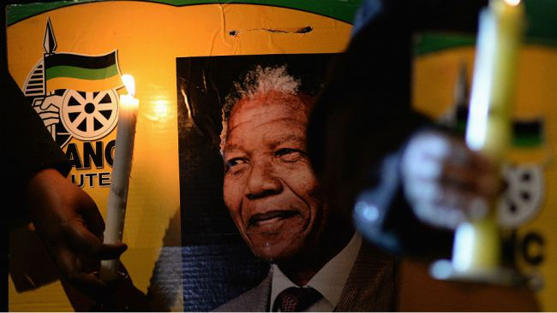“People are trapped in history, and history is trapped in them,” James Baldwin wrote. Few men have had as much history trapped in them as Nelson Mandela.
To those outside South Africa, the country has been reduced to Nelson Mandela just as it was once reduced to apartheid. Mandela was the ending to a story that everyone thought they knew. With his death, the story comes perilously close to losing its meaning.
The history trapped in Mandela escapes with his death forcing both those inside South Africa and those outside it to come to terms with all the complex realities of history packed away into one man’s life.
Like Gandhi, Mandela became an iconic figure who appeared to encompass the moral of his own story. The fictional Nelson Mandela has appeared in dozens of movies. He has been played by everyone from Danny Glover to Sidney Poitier to Morgan Freeman. And each of those movies has made the real man and the real South Africa that he leaves behind in death seem that much more unreal.
Western liberals like simplistic stories and Mandela was their happy ending. His very existence freed them from the need to learn anything more about what happened after apartheid. By knowing him, they knew, as Paul Harvey would say, the rest of the story. Mandela freed them from knowing history.
Everyone knows the history of South Africa and no one knows it. The dynamics of a troubled past that were reduced to a happy ending built around one man are still playing out in South Africa. Even as the mourning for Mandela goes on,one child is raped every three minutes in South Africa and three children are murdered every day.
If there is anything that the world ought to mourn, not only today, but every day, it is a horrifying reality in which a South African woman is more likely to be raped than to learn to read, a quarter of the men admit to having raped and men with AIDS believe that they can find a cure by raping a baby.
Troubling facts like these defy the easy inspiration of the happy ending. They remind us that history does not stop the way that a film script does. There is no moment when the crowd cheers, the camera pans up and the audience is free to leave the theater and look no further because the story has ended.
South Africa’s story did not end with apartheid. It does not end with Mandela’s death. South Africa remains in twilight. The credits do not roll. The happy ending has not come.
The Mandela era gave way to the Mbeki era and the Zuma era. Mbeki had been trained in the USSR and Zuma, like Mandela, had been a member of the Communist Party. Their rule was characterized not only by corruption and violence, but by the denial that the corruption and violence existed. Mbeki claimed that HIV was not linked to AIDS and that those pointing out the escalating crime rate were white racists. Zuma has said that the child rapes are “inexplicable”; but had been put on trial for raping an HIV-positive AIDS activist while claiming an equally magical way of preventing the disease.
Just as Mbeki’s successor was worse than him so too Zuma’s successor is likely to be worse than his predecessor. The difference between South Africa and Zimbabwe is only one of degree. And to prove that very point, Zuma has praised Zimbabwe’s Mugabe calling him a fellow freedom fighter.
In his address to the nation, Zuma said that, “What made Nelson Mandela great was precisely what made him human. We saw in him what we seek in ourselves. And in him we saw so much of ourselves.”
There is certainly some truth to that. But it is not a truth about Nelson Mandela. It is a truth about people who are caught up in chaos and searching for something to believe in. Zuma said that South Africans, “mourn the loss of the one person who, more than any other, came to embody their sense of a common nationhood.” But the unpleasant truth is that there is no more South African nationhood.
The more liberals wanted South Africa to escape from its own history, the more it became trapped in real problems with no easy solutions.
South Africa is just as divided by race as it was when Mandela was in prison. It is broken up into countless tiny factions protected by real and metaphorical violence. There is no trusted institution in the country that unites it. There is no trust by South Africans in each other.
When a farmer’s family is brutally murdered by his own workers and men rape the children of their neighbors in the hopes of curing themselves of AIDS—there can be no such thing as trust. The story told in so many of the movies where Mandela played by Sidney Poitier or Morgan Freeman teaches blacks and whites to set aside their hatred has not worked out nearly as well in real life.
In the new apartheid, the black government represses a white minority and abuses its power over the black majority in ways that Western liberals would never tolerate if it were being practiced by men with Dutch last names. Every government crime is covered up by more incitement against the white minority with each generation of activists struggling to outdo the previous generation in its anti-white racism.
There has been no moment of transcendence that endured. No cure for the things tearing the nation apart. There is no new spirit in South Africa. There is a new apartheid defined not by law, but by hate. Freedom and democracy are equally vaporous under the rule of a political movement obsessed with the vicious pragmatism of power now being exercised by Mandela’s African National Congress successors.
“People pay for what they do and still more for what they have allowed themselves to become,” Baldwin wrote. “And they pay for it very simply by the lives they lead.” There is no place where that is quite as true as in post-apartheid South Africa where the violence unleashed still haunts the townships.
In working nations, the death of a Mandela would create a symbol. In South Africa, it removes one of the few fragile symbols whose meaning is as disputed as everything else about the post-apartheid era.
For Western liberals, Mandela’s death provides them with permission to stop caring about South Africa. Having reduced South Africa to Mandela, his death permanently removes its existence from their minds. They may show up to the theater if Denzel Washington or Jamie Foxx decide to play Nelson Mandela. Otherwise they will comfortably banish the entire country to the dusty attic of forgotten history.
Meanwhile one child is raped every three minutes and three children are murdered every day.

http://www.frontpagemag.com/2013/dgreenfield/south-africa-in-the-shadows/

