aangirfan
Disclaimer: the posting of stories, commentaries, reports, documents and links (embedded or otherwise) on this site does not in any way, shape or form, implied or otherwise, necessarily express or suggest endorsement or support of any of such posted material or parts therein.

Saturday, December 07, 2013

THE MURDEROUS MANDELAS
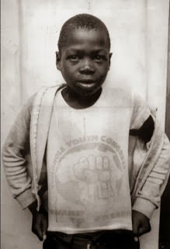
Stompie
Stompie was reportedly a Mandela victim.
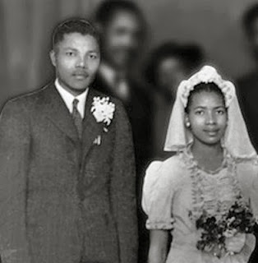
6'4" tall Mandela and his first wife Evelyn Mase in 1944
It is as if there were two Mandelas.
The Mandela who went into prison was reportedly six foot, four inches tall.
The Mandela who came out of prison was reportedly about five foot, nine inches.
I Believe Nelson Mandela Had Already Died - Godlike Productions
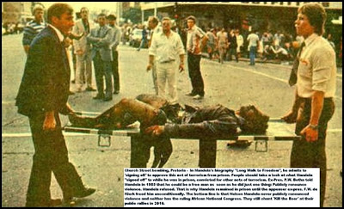
Victim of Mandela
Nelson Mandela's terrorists planted bombs in public places, thus killing women and children.
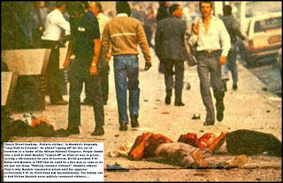
Victims of Mandela.
Mandela's first wife was Evelyn.
Mandela flaunted his girl friends in front of Evelyn.
According to Evelyn: "There was another woman and this one started coming home, walking into our bedroom, following him into the bathroom . . . I declared that I would not allow it."
The ballroom dancing ladies' man with a very tempestuous love life
It was reported that Mandela had an illegitimate son.
In her divorce petition Evelyn accused Mandela of beating her, throttling her, and threatening to attack her with an axe.
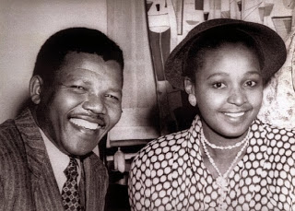
Nelson and Winnie
Before
the divorce, in 1958, Mandela had taken up with Winnie and they eventually married.
Winnie was Mandela's sort of woman.
In 1964 Mandela was jailed for life.
When Winnie was allowed to return to Johannesburg in 1986 she became a murderous gangster.
Winnie called for her followers to attack their enemies with 'matches and their necklaces' - tyres filled with petrol, put around people's necks, and set on fire.
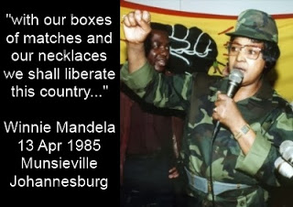
Winnie set up Mandela United, a militia which recruited thugs from the townships.
These thugs were used to terrorise Black people.
These thugs would kidnap Blacks and take them to Winnie's home, a large mansion surrounded by electric fences.
Winnie liked to whip her captives, put plastic bags over their heads and then have them disposed of.
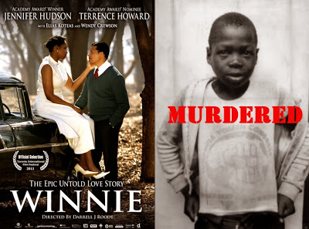
Stompie (right) The Truth About South Africa.
Winnie was accused, by one of her bodyguards, of having played a part in the murder of Stompie Sepei Moetesky, a 14-year-old boy.
Stompie was tortured and his throat was cut.
His body was found next to Winnie's house in 1989.
The ballroom dancing ladies' man
Many other boys were murdered, reportedly by Winnie's gang.
In 1998, Mandela married Graca Machel, the former wife of Mozambique's president.
Nelson Mandela has been accused of giving no affection to his children, some of whom have died in tragic circumstances.
Read more: http://www.dailymail.
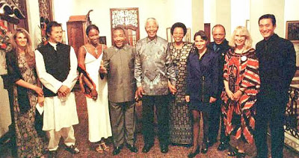
At least two of these people are said to be spooks: Jemima Khan, Imran Khan, Naomi Campbell, Charles Taylor (CIA), Nelson Mandela (MI6), Gracha Machel, Quincy Jones, Mia Farrow and Tony Leung
Nelson Mandela is said to have worked for MI6.
MANDELA THE SPOOK
Above we see Nelson Mandela and his friend Charles Taylor.
Charles Taylor helped to finance the attacks of 9 11 in the USA.

(Liberia's Taylor gave aid to Qaeda, UN probe finds - The Boston Globe)
From the early 1980s onwards, Charles Taylor worked for the USA's Defence Intelligence Agency.
In January 2012, this was confirmed by the Pentagon, thanks to a Freedom of Information request from the Boston Globe.
http://www.dailymail.co.uk/news/article-2088010/Former-Liberian-dictator-Charles-Taylor-worked-U-S-intelligence-Africas-notorious-warlord.html#ixzz1jnYsRGR9
Stompie
When Nelson Mandela became President of South Africa, crime and poverty increased.
Journalist John Pilger, in his book 'Freedom Next Time', tells us:
1. South Africa is rich in minerals.
2. The average black household income has fallen by 19% since independence.
3. "The unspoken deal was that whites would retain economic control in exchange for black majority rule."
4. "Before 1994, there were secret meetings in Britain between Thabo Mbeki, the white elite and the big global companies with links to South Africa.
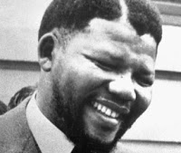
Mandela the capitalist terrorist
5. Mandela said to Pilger:
"We do not want to challenge big business that can take fright and take away their money . . .

"You can call it Thatcherite but, for this country, privatisation is the fundamental policy."
Pilger writes of Mandela that "as the first liberation president, he ordered a ridiculous and bloody invasion of tiny Lesotho.
"He allowed South African armaments to be sold to Algeria, Colombia and Peru, which have notorious human rights records.
"He invited the Indonesian mass murderer General Suharto to South Africa and gave him the country's highest award . . . He recognised the brutal Burmese junta as a legitimate government."

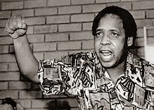
Chris Hani
Mandela was anti-communist.
Winnie Mandela has claimed that the Mandela faction within the African National Congress conspired with the people who murdered the South African Communist leader, Chris Hani in 1992.

"There are some in the ANC who believe ANC members had something to do with Hani's assassination.
"Winnie Madikizela-Mandela was reported in the London Sunday Times, a week after the assassination, to have told confidants she believed moderate ANC leaders had conspired with the National Party government to eliminate Hani.

"The report said: 'according to her, details of Hani's movements, including critical information about when his bodyguards would be absent, were passed to government security agents, who in turn made this known to Waluz [Hani's killer, FB]'."

Who Killed Chris Hani?
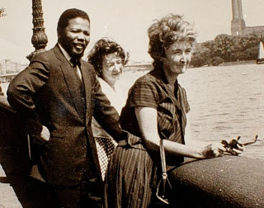
Nelson Mandela in London with Freda Levson and Mary Benson. dailymail.co.uk/

Nelson Mandela spent ten days in London in 1962.
At this time he was the most wanted man in South Africa, as he was the boss of the armed (terrorist) wing of the African National Congress.

In London, Mandela met with Denis Healey a member of Bilderberg who was at one time the cabinet minister in charge of Defence.

Mandela in London

Nelson Mandela reportedly worked for MI6

MANDELA THE SPOOK

There is a suspicion that Mandela's London trip was being organised by MI6.
Nelson Mandela was taken around London by Mary Benson.

Mary Benson, who lived in posh St John's Wood in central London, and who was of South African origin, became Mandela's official biographer.

Mary Benson had worked for the British army and she was a friend of Denis Healey.

Mandela in London

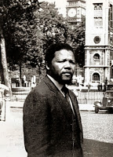

Mary Benson said of Mandela: "He had been visiting the different countries in Africa ... and getting some military training..."
Mandela in London.

With Mary Benson and Mandela on their tour of London were South African activists Freda and Leon Levson.
Zoleka mandela (left)

Zoleka Mandela wrote: 'From the time I was barely eight years old to the age of 14, I had been sexually abused by some of the adults who should have been looking after me."
Nelson Mandela's granddaughter
South Africa is famous for its child sex rings.
Gert van Rooyen / Child Sex Industry Booms In South Africa
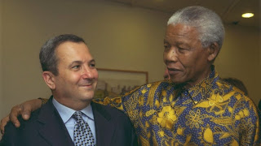
Multi-millionaire Mandela
Nelson Mandela is as fake as Tony Blair or Jimmy Savile.
Nelson Mandela's family are rich capitalists.
His children and grandchildren are active in more than 100 companies and hold their wealth in a number of trusts.
Some of the trusts own expensive properties in Johannesburg.
The Mandelas are involved in a Mandela clothing range, minerals, the controversial Aurora mine, real estate, railway engineering, medical firms, and entertainment.
Mandela family rakes in millions
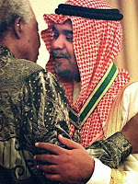
Mandela, said to be worth over £10 million, and Prince Bandar. Saudi prince Bandar led attacks on Syria Christians.
The owners of the Aurora mine have been accused of abusing their workers and selling mine assets they do not own.

The managing director of Aurora is Zondwa Mandela, grandson of Nelson Mandela.
Despite having no previous experience in the mining industry, a high court-appointed liquidator gave Aurora control of two gold mines...
BBC News - Mandela and Zuma gold mine 'exploiting workers'
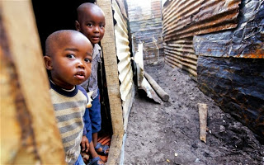
Eighteen years after the end of apartheid, South Africa is now judged to be one of the most unequal societies in the world. More than half of South Africa's children live in dire poverty
According to South African novelist Zakes Mda:
"The disillusionment of young black South Africans began when Nelson Mandela was president.

"So did the unbridled accumulation of wealth by the ruling party apparatchiks, accompanied by the marginalisation of all those deemed to lack 'struggle credentials'.
"While cadres of the party gained positions of power and wealth, both in the public and private sectors, the rest of the black population remained poor and out of work.
Nelson Mandela: no saint
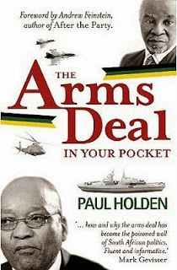
When Mandela came to power, his government bought lots of weapons.
"In the case of BAE Systems, R300m had allegedly been paid in kickbacks, while in the case of the German Frigate Consortium, a payment of $25m was said to have changed hands."
An update on the Arms Deal.
Whistleblower Patricia de Lille alleged in Parliament that she had evidence of three payments by warship supplier Thyssen-Krupp on 29 January 1999, each of R500,000, to the ANC, to the Nelson Mandela Children's Fund and to the Community Development Foundation, a Mozambique charity associated with Mandela's wife, Graça Machel.[3]

Reportedly, about $1.5 million has been misappropriated from the Nelson Mandela Children's fund.

Police investigate alleged £1m fraud from Nelson Mandela's charities.
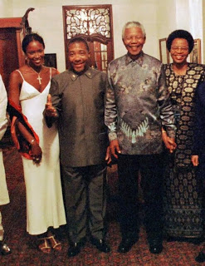
The CIA's Charles Taylor with MI6's Nelson Mandela.
"Some of these former African leaders are compromised by the money they get from those who finance their fake Foundations and charities which are just an excuse for flying around the world and keeping themselves in the limelight."
The Nelson Mandela conspiracy theory | Zambian Eye
Mandela's government was involved in huge arms sales to countries such as Rwanda, where a million people were killed, and to the Congo where three million were killed.
NELSON MANDELA.
Below we see how South Africa has slipped in terms of the Human Development Index.
Human Development Index for South Africa - Alistair Pott.
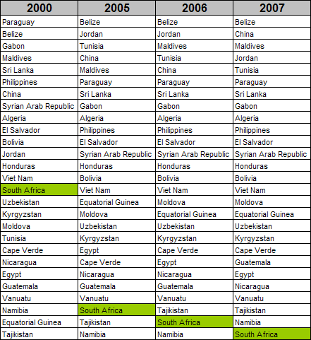
According to South African missionary Dr Peter Hammond:

1,000 Africans were killed by necklacing (burning alive) carried out by Mandela's ANC

Nelson Mandela: A Terrorist?

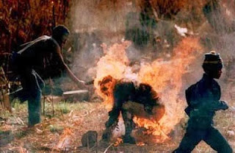
Necklacing
Hammond has described acts of violence committed by the ANC under the order or oversight of Mandela.

"Missionaries and their kids were murdered, bayoneted on the fields - whole families killed by landmines planted in the roads...

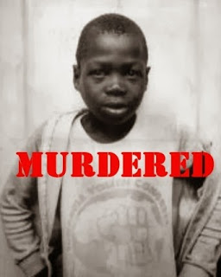
Stompie, murdered by Winnie Mandela

"Winnie Mandela actually was found guilty in court of the murder of a 12-year-old boy.

"And it was upheld on appeal. She was sentenced to five years in prison, but she hasn’t served a day."

Nelson Mandela: A Terrorist?
"The Church Street attack on May 20, 1983 killed 19 and injured more than 200 people when a car with 40kg of explosives was detonated...
"In his book Long Walk to Freedom, Nelson Mandela wrote that as a leading member of the ANC’s executive committee, he had 'personally signed off' in approving these acts of terrorism.

Nelson Mandela: A Terrorist?

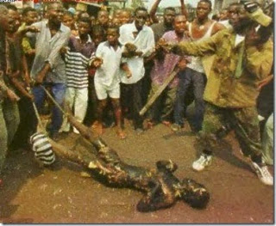
The ANC teaching youths "how to terrorise resistant township residents into submission to ANC-hegemony."

Mandela refused to renounce violence.

Amnesty refused to take his case stating "that it could not give the name of 'Prisoner of Conscience' to anyone associated with violence..."

Nelson Mandela: A Terrorist?
According to David Horowitz:
"South Africa is the murder capital of the world, a nation where a woman is raped every 30 seconds, often by AIDs carriers who go unpunished..."

Nelson Mandela: A Terrorist?

