'Mandela Legacy: Mass Murderers Had Slates Wiped Clean'
Nels Abbey takes objective look over post-apartheid era and compares forgiveness to justice
Written by Nels Abbey
18/12/2013 10:47 AM
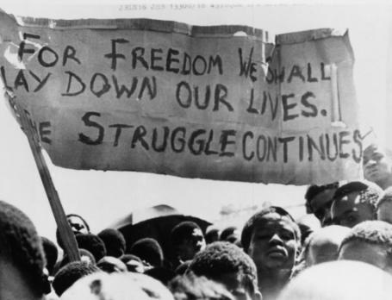
FIGHT FOR FREEDOM: A banner is held aloft above black students in Johannesburg, South Africa, in the township of Soweto where they rallied after the funeral of a 16-year-old black student who died in jail (Oct 18, 1976). The student, Dumisani Mbatha, who was arrested following a protest march last month by young blacks in Johannesburg, died two days after his arrest on Sept. 23, 1976 (PA)
I GENUINELY love and admire Nelson Mandela. To some degree, I’m inspired by him. But I cannot help but feel saddened by parts of his legacy.
In just about every news report on his passing, he is praised for his unique ability to forgive. They say as president he pursued an agenda of reconciliation over revenge. This narrative has left me with one question: exactly when did "justice" become "revenge"?
I always thought when people did wrong (mass murder, assassinations, torture, kidnapping, extrajudicial killings, for example) they were punished accordingly.
I was taught that it’s a concept known as justice. Apparently punishing the racists, criminals and gangsters of apartheid South Africa is a now known as "revenge".
As I type this, western news reporters are literally fighting back tears, praising Nelson Mandela’s "unique ability to forgive and reconcile."
But it must be said: no western leader would ever in a million years allow those that waged terror on his people to go unpunished. No westerner would accept it. We’d be spitting on Winston Churchill’s grave if he had called for "forgiving and reconciling with the Nazis".
Would President George Bush have won a second term as president if he had told his people to "forgive and reconcile" with Al Qaeda? America’s ability to bear a grudge is legendary – as Iran, Cuba, Libya, Syria and many others can surely attest.
If I admire anything about the state of Israel it is that they still, to this very day, go to every corner of the globe to ensure that those who terrorised their people in the Holocaust are brought to justice.
And they have vowed, in word and action, that it will never happen to them again. That must be respected.
Nelson Mandela created a legal and cultural environment in which mass murderers, terrorists and brutal racists had their slates wiped clean simply by publicly confessing to their crimes.
They didn’t even have to apologise. Some of them became talk-show-circuit-celebrities for their crimes. Put yourself in the shoes of a mother switching on the TV to see the self-confessed murderer of her child being welcomed to the equivalent of the Wendy Williams Show (complete with a black host) as "the honourable assassin" (Dirk Coetzee in this instance).
Only Africans would have to tolerate this. Only African people would be considered capable of forgiving a form of genocide. As funny as it may sound, African elephants would get justice.
How does that impact the psyche of the African? How is the African left to think anything other than that her suffering, her pain and even her life is worth less than that of a westerner’s?
The problem is that these pains do not go away. Where there is no justice there is really no peace - it is not an empty slogan. It has deep literal meaning.
Silently smiling in the face of suffering and injustice does not reflect peace. It reflects furious farce. And sadly quite often we find black Africans (everywhere) taking this historical psychological baggage out on each other, often violently.
So the apartheid era criminals and the apartheid criminal regime’s economic and social order remain comfortably in place. Exactly what did Mandela change?
A lot, obviously. He made South Africa a universal democracy, enshrined legal equality, granted better access to education and housing, job creation and the destruction of a system of horrific legally imposed racism.
Nevertheless, it amazes me that regardless of whatever ills we are faced with, be it slavery, colonialism, apartheid, Jim-Crowism, segregation or overt imperialism, when we get over it, when we finally conquer it, the social and economic order always seems to remain firmly intact. And black people are firmly in the weaker position.
Perhaps we are too timid or sympathetic. Perhaps we have a natural disposition to be loved. Perhaps we have focused too much on symbolic change than on actual change. Or maybe we have been rendered too weak to fight.
Whatever the case may be, had Nelson Mandela done what it takes to inflict actual social, systemic, cultural and economic change he would be likely to be remembered in Mugabe-esque terms today.
Or, as happened to many others (such as Thomas Sankara, Kwame Nkrumah, Patrice Lumumba, Malcolm X and, indeed, Winnie Mandela) he would have been politically or literally annulled.
So what now? Mandela’s legacy is now in our hands. For Africans everywhere Mandela’s legacy is what we make it. We own his legacy because we are his legacy.
We must work and indeed fight to ensure that his work, as well as the work and sacrifices of millions of unnamed people, unnamed heroes, does not now go in vain.

http://www.voice-online.co.uk/article/mandela-legacy-mass-murderers-had-slates-wiped-clean

